**Software Engineering**

Assignment # 01



Submitted from: Fahad Ali Khan

Roll No: 153177

Submitted to: Sir Ahmad Mohsin

Submission Date: 18-09-2017

**BSCS-V**

**Exercise = 0 &1**

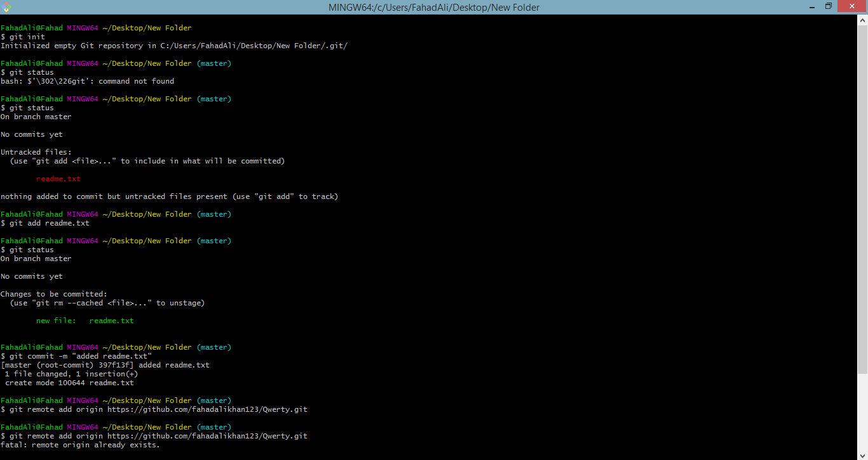

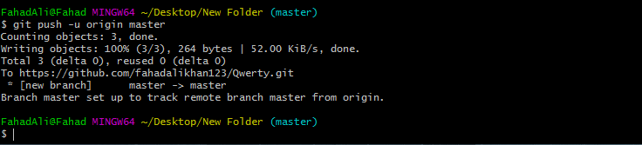

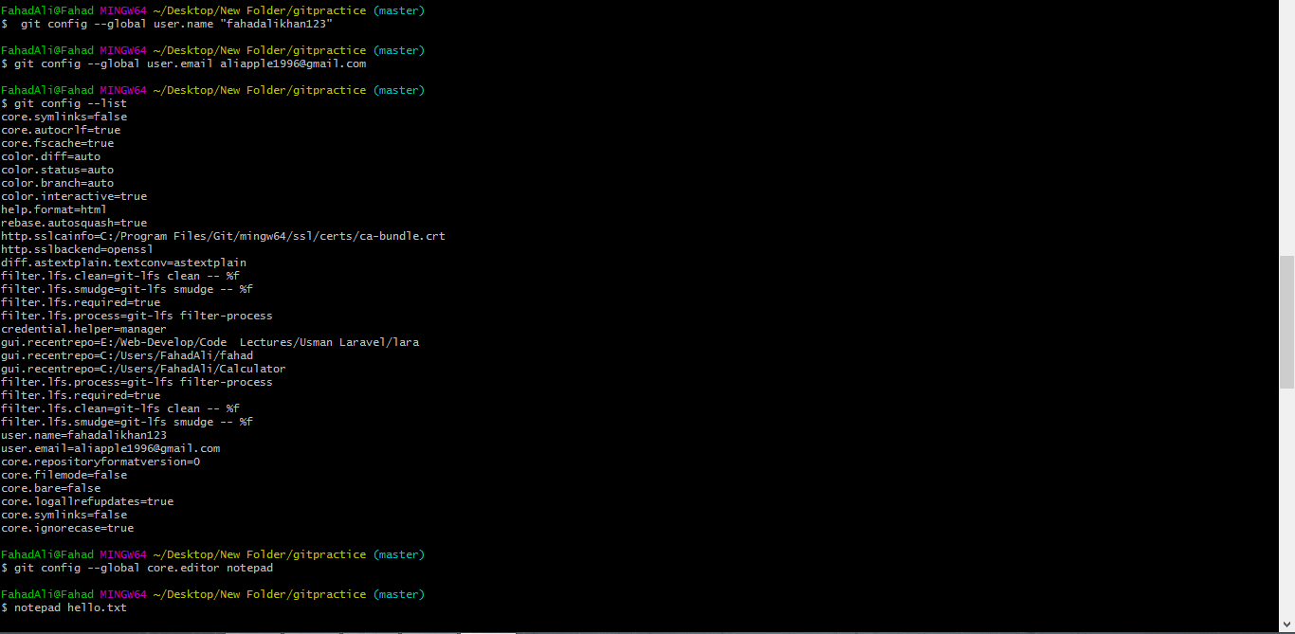

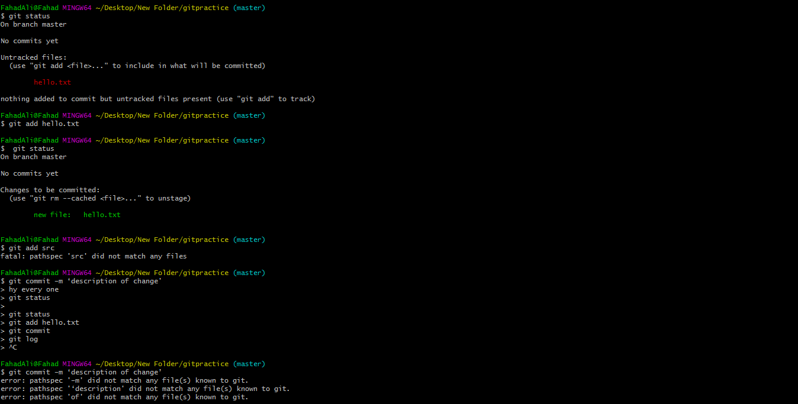

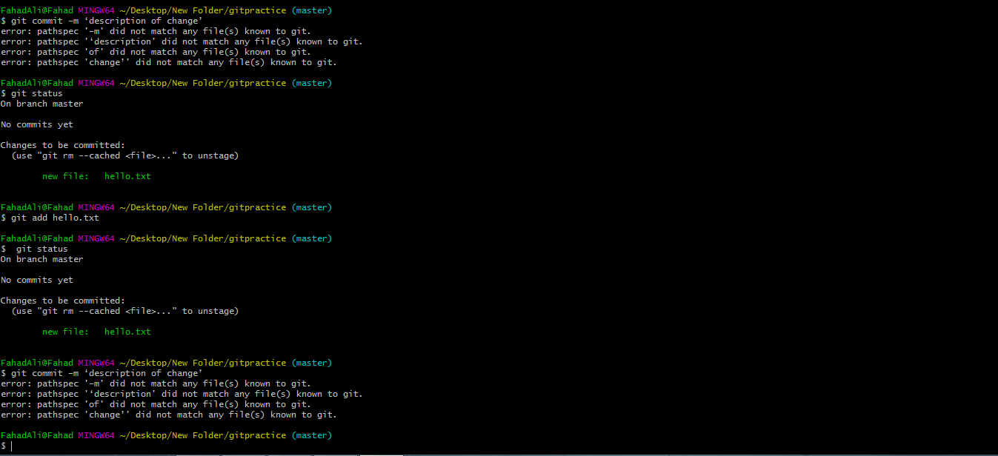

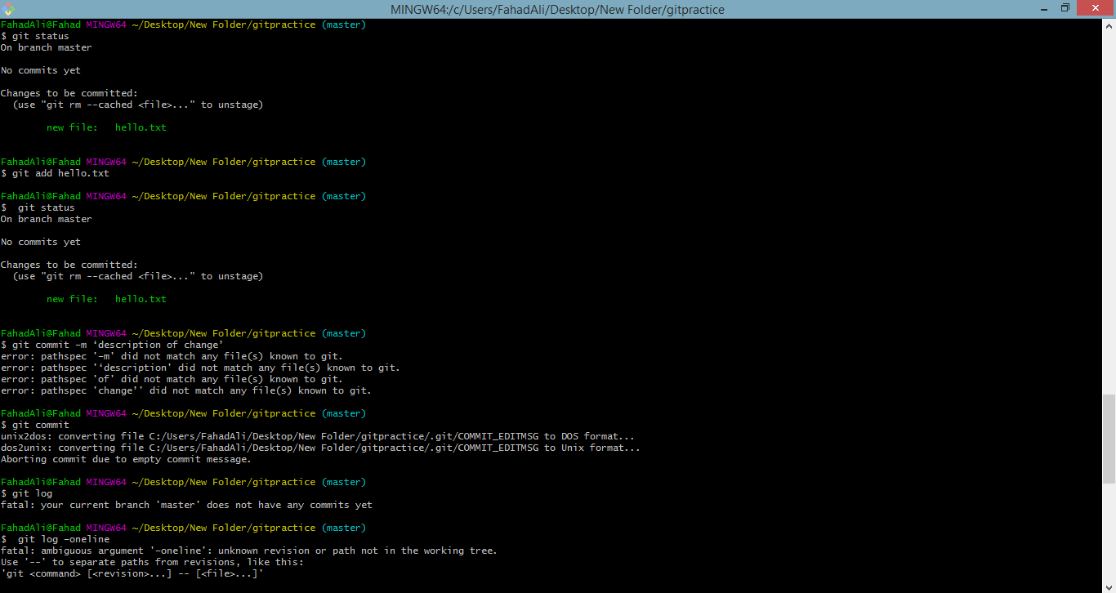



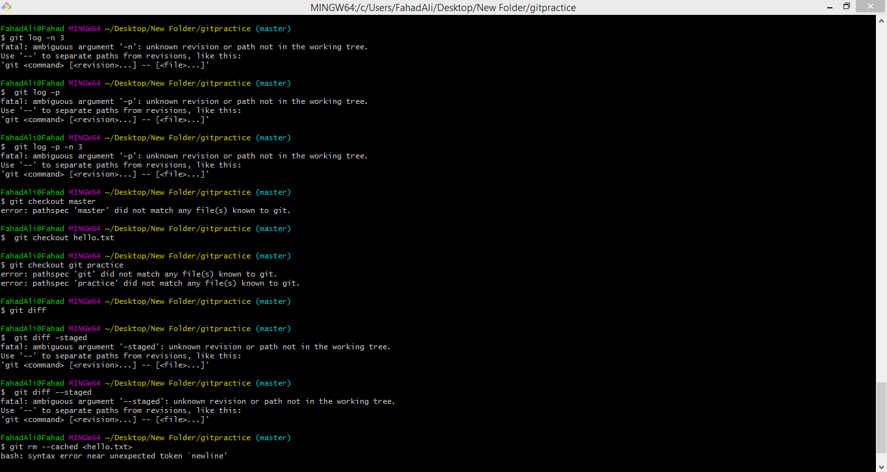

**Exercise = 2**

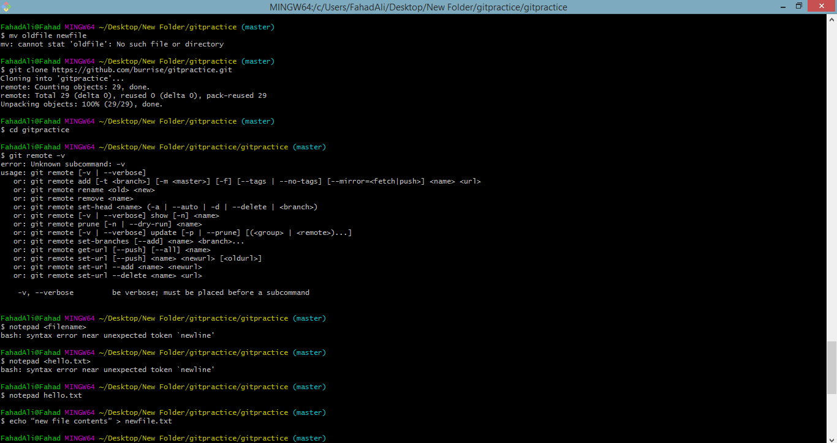

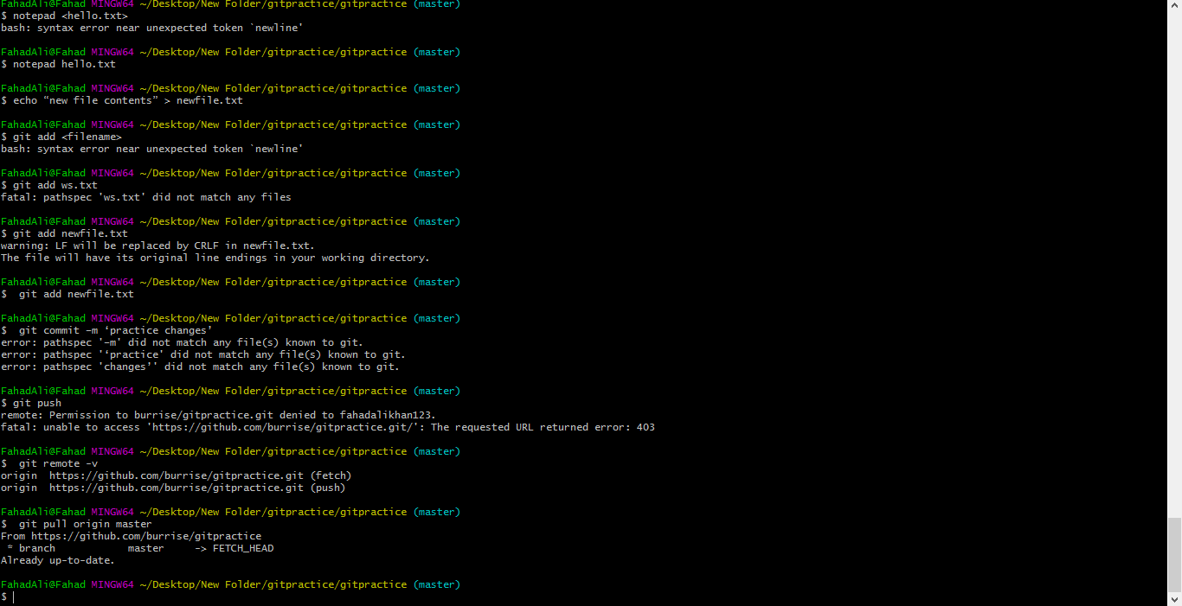

**Exercise = 3**



